Mid-Semester Project Report: DIY Environmental Sensor System for T / RH / CO2 Monitoring
Student Name: Shelby Kaplan
Course: Envirotech - DIY sensors for environmental research
Professor: Prof. Elad Levintal, Teaching Assistant: Robel Kahsu Adane
GitHub Repository Link: https://github.com/shelbyar-png/Envirotech-Mid-Semester-Project/tree/main

1. Introduction & Experimental Design
Continuous microclimate tracking via open-source, low-cost environmental sensor arrays has become vital for environmental monitoring, as it democratizes data collection, allowing researchers and hobbyists alike to measure small-scale environmental variables—such as temperature, humidity, and CO2 concentration--over extended periods without relying on expensive, proprietary instrumentation.
The primary goal of this project was to construct an open-source environmental data logger capable of collecting continuous microclimate parameters on an SD card over a three-day deployment. To achieve this, a custom hardware stack was constructed using an Arduino Uno microcontroller interfacing with an Adafruit SHT40 breakout board for temperature and relative humidity alongside a Sensirion SCD30 module for carbon dioxide sensing, in addition to secondary temperature and humidity sensing. sensing). Data storage was handled locally via an SPI-driven MicroSD card breakout board configured to write data to a localized CSV file structure.This hardware array was deployed continuously for three days inside a residential home in Midreshet Ben Gurion, Israel, positioned on a desk adjacent to an open sliding glass window door that was open .

2. Bill of Materials (BOM)

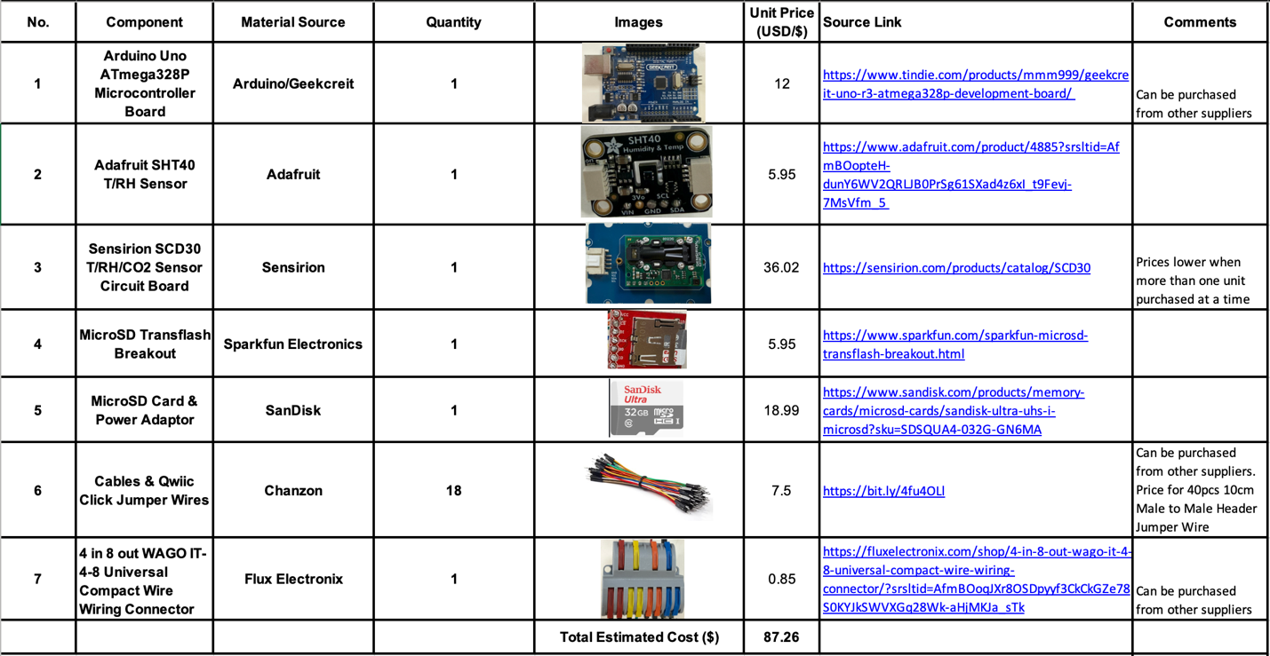

3. System Hardware

3.1 Connection Diagram

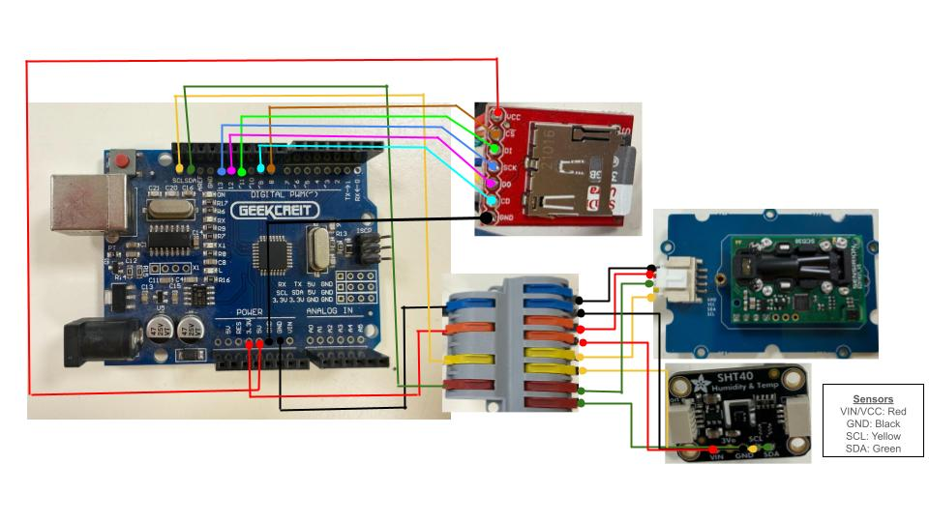

3.2 Assembled System and placement

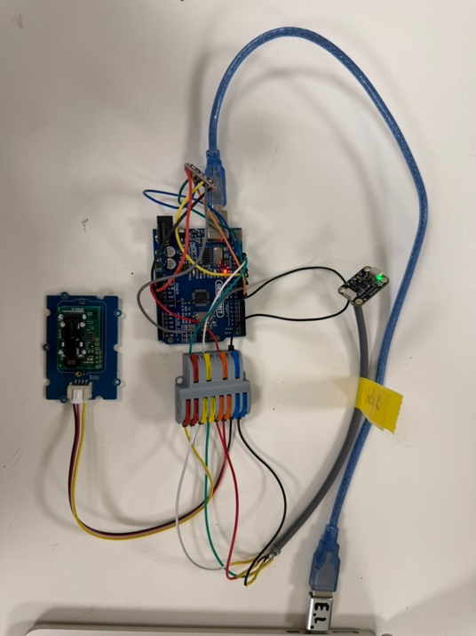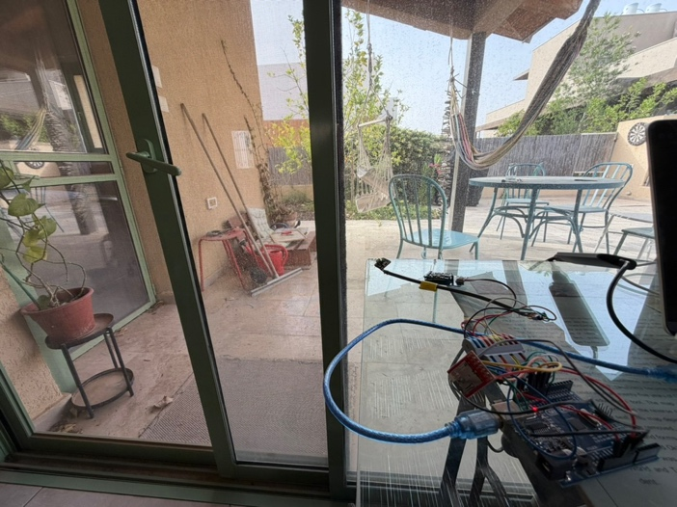

4. Results & Discussion
Figure 1: Temperature Inter-comparison (SHT40 vs. SCD30 vs. IMS Sde Boker Station Baseline)
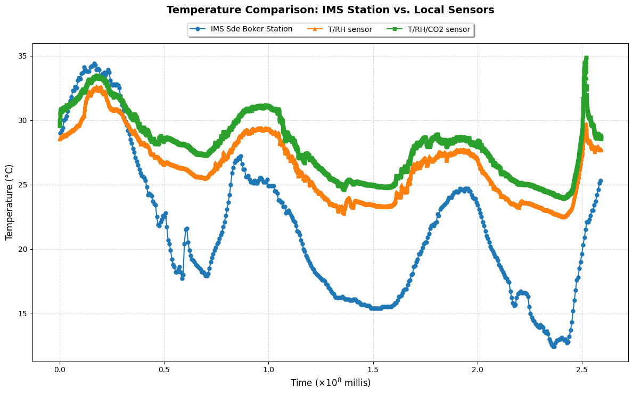
Figure 2: Relative Humidity Dynamic Performance
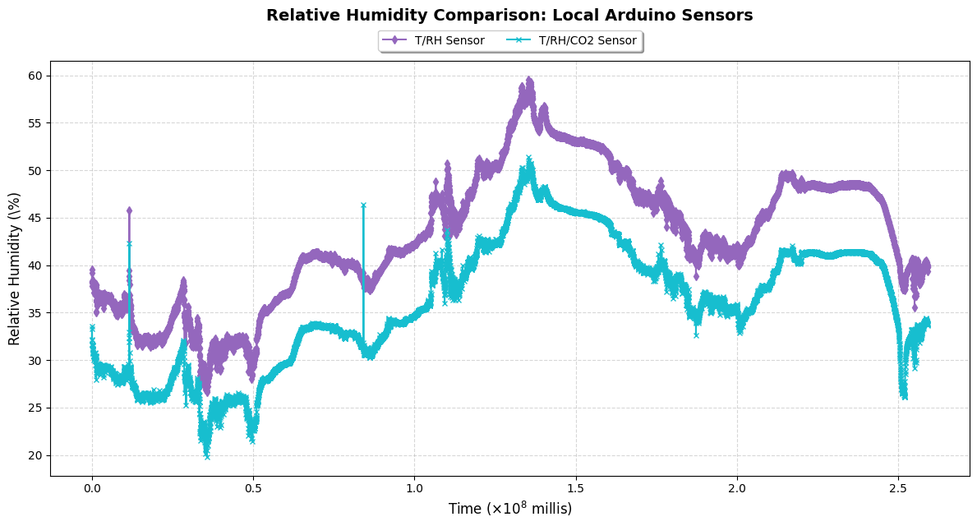

Figure 3: Carbon Dioxide (${CO}_{2}$) Concentration Over Time (Raw vs. Outlier Filtered)
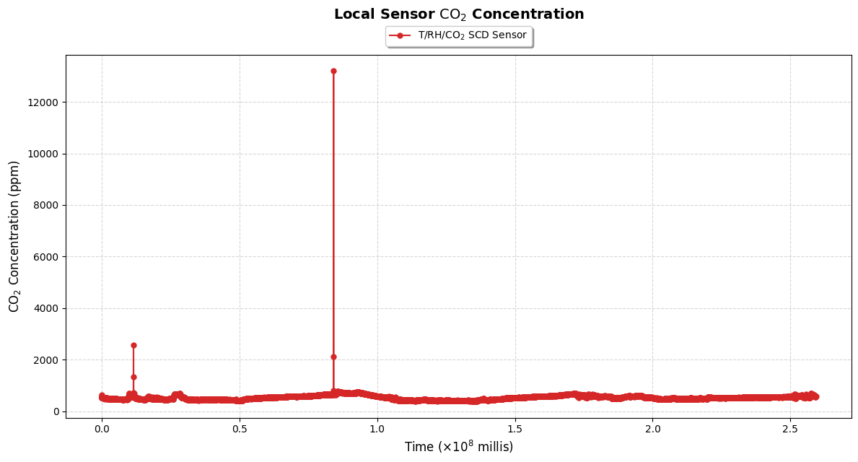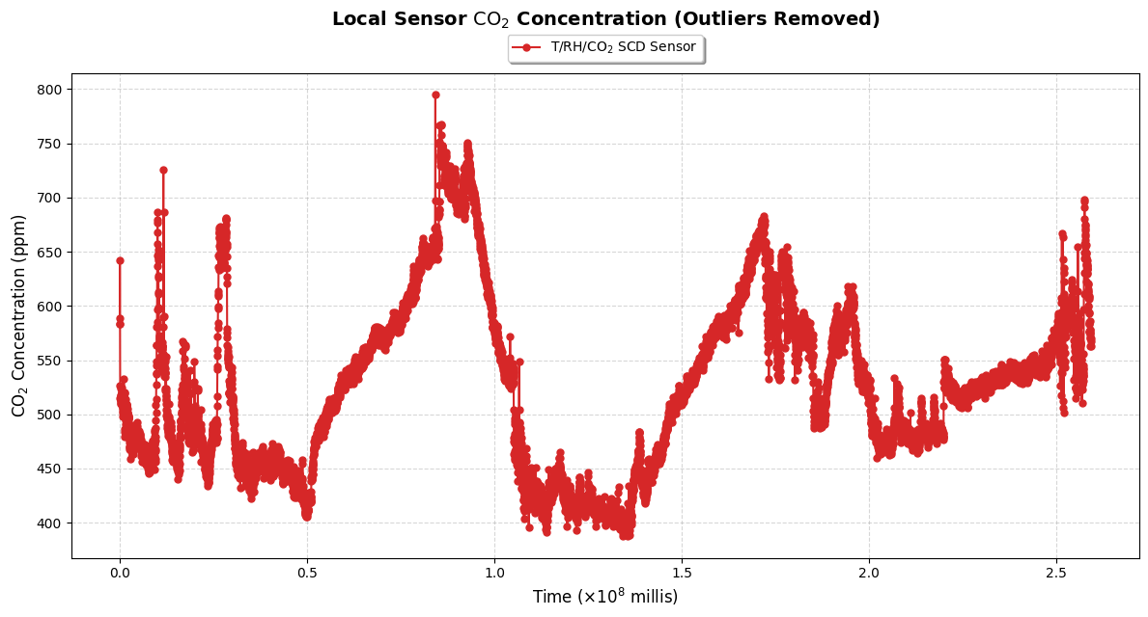

The three-day continuous deployment captured both broad microclimatic trends and highly localized indoor events. In general, the locally recorded temperature (Figure 1) and relative humidity (Figure 2) tracked the cyclic diurnal patterns of the surrounding region, though indoor temperatures remained consistently insulated compared to the sharp dips recorded by the nearby meteorological station. While indoor carbon dioxide levels baseline-fluctuated safely between 400 ppm and 800 ppm across the deployment, two distinct, extreme anomalies were observed in the data stream where concentrations abruptly spiked to over 12,000 ppm within a tight 30-second window. Rather than a systemic hardware malfunction, these spikes represent controlled, localized testing anomalies where direct human breath was exhaled onto the optical sensor chamber, verifying the acute sensitivity and rapid response time of the completed logger stack.

5. Conclusion
This project successfully demonstrated the compilation, deployment, and operation of a low-cost, open-source environmental sensor array over a continuous three-day deployment period in Midreshet Ben Gurion. Despite minor timing adjustments necessitated by the I2C sensor data-ready constraints—which shifted the sampling window from 30 seconds to a stabilized 27 seconds—the data logger exhibited high stability without dropping log points. The collected data proved that a DIY hardware stack can reliably track indoor microclimate trends while remaining sensitive enough to capture immediate, localized human interaction—such as intentional breath exhalation spikes. However, to strictly validate the exact data quality and accuracy of these low-cost sensors over time, the system should be deployed alongside higher-grade, scientifically calibrated instrumentation for rigorous cross-calibration and baseline verification.

